

Data Warehousing & Business Intelligence (IT)

3rd Year, 1st Semester

# Assignment 1

Submitted to

Sri Lanka Institute of Information Technology

IT20035358

K.N.N.D.S Jayarathna.

Weekday Batch

**STEP 01: Data set selection**

I have selected the predicting Coupon Redemption data set as the data set. It consists of seven csv files. Among them I chose five csv files to implement my solution.

According to the assignment guidelines the data set was initiated with sufficient data. In my data set which I have selected is a transactional data type and it is used to predict whether customer will Redeem coupons such as discounts coupons or other types of coupons released in various marketing campaigns.

Customer, Campaign, Items and coupon redemption status and customer transaction are all detailed in the data set.

In predicting coupon redemption data set, there are also enough records and attributes to build complete data warehouse and perform ETL process. I can receive two sources of data from the data set that I have selected (A database and a text file) as my source data. And the data set is sufficient to build data warehouse and I was able to do ETL process with this data set.

As well as I can correctly identify hierarchies, dimensions, and aggregates in the data set. I also identified that with data set I will be able to generate appropriate reports.

* Data set link: -

<https://www.kaggle.com/datasets/vasudeva009/predicting-coupon-redemption>

* **Data Description**
* Train.CSV

|  |  |
| --- | --- |
| Variable | Definition |
| id | Unique id for coupon customer impression |
| campaign_id | Unique id for a discount campaign |
| coupon_id | Unique id for a discount coupon |
| customer_id | Unique id for a customer |
| Redemption_status | (target) (0 - Coupon not redeemed, 1 - Coupon redeemed) |

* Campaign_data.csv

|  |  |
| --- | --- |
| Variable | Definition |
| campaign_id | Unique id for a discount campaign |
| campaign_type | Anonymised Campaign Type (X/Y |
| start_date | Campaign Start Date |
| end_date | Campaign End Date |

* customer_demographics.csv

|  |  |
| --- | --- |
| Variable | Definition |
| customer_id | Unique id for a customer |
| age_range | Age range of customer family in years |
| marital_status | Married/Single |
| rented | 0 - not rented accommodation, 1 - rented accommodation |
| family_size | Number of family members |
| noOfChildren | Number of children in the family |
| income_bracket | Label Encoded Income Bracket (Higher income corresponds to higher number |

* customertransaction.csv

|  |  |
| --- | --- |
| Variable | Definition |
| date | Date of Transaction |
| customer_id | Unique id for a customer |
| item_id | Unique id for item |
| quantity | quantity of item bought |
| selling_price | Sales value of the transaction |
| other_discount | Discount from other sources such as manufacturer coupon/loyalty card |
| coupon_discount | Discount availed from retailer coupon |

* Item.csv

|  |  |
| --- | --- |
| Variable | Definition |
| item_id | Unique id for item |
| brand | Unique id for item brand |
| brand_type | Brand Type (local/Established) |
| Category | Item Category |

* **ER Diagram**

**STEP 02: Preparation of Data Sources**

There were seven csv files available in the data set. They are,

* + Item data csv
  + Customer Demographics csv
  + Customer Transaction Data csv
  + Campaign Data csv
  + Train Data csv
  + Coupon Item Mapping csv
  + Test csv
* Among these csv files Item Mapping and Test csv files were not taken to create tables.
* And I decided to convert Campaign data csv into text file format.
* Then I imported all other four csv files into my CouponRedemption_SourceDB.
* After I imported my csv files into sourceDB, I created Data warehouse named CouponRedemption_DW and created my dimension tables and fact tables inside the data warehouse.
* Here I converted train csv file data into CouponRedemption table.

**campaign _data.csv customer_demographics.csv**

**Customer_transaction_data_new.csv**

**item_data.csv train.csv**

**campaign_data.csv campaign_data.txt**

I have loaded customer_demographics.csv, customer_transaction_dat_new.csv, item_data.csv and train.csv files to the DB called CouponRedemption_SourceDB.

**CouponRedemption_SourceDB**

**The campaign_data.csv details were taken as s text file, and I used It as another sourceType.**

**Campaign_data.csv Campaign_data.txt**

**STEP 03: Solution Architecture**

* + The data warehouse is the core of the BI system. A data warehouse is a purpose of data analysis and reporting. This purpose changes the design of this database as well.
  + This architecture shows the high-level BI solution to the warehouse.

**STEP 04: Data warehouse Design and Development**



**Assumptions**

* I used a schema type of **Snowflake schema** for the Data warehouse development. At there,
* There is one Fact Table, it is **FactCustomerTransaction** table.

There are five dimensions table.

* 1. DimCustomers table
  2. DimItem table
  3. DimDate table
  4. DimCouponRedemption table
  5. DimCampaign table
* I have taken **DimCustomers** details as slowly changing dimension, **Income bracket** can change time to time, and we need to keep track of their historical data.
* I have implemented data warehouse tables in the SQL server and the tables that I have created shown below

**Data Warehouse Data types**

* Before creating the FactTransaction fact table and other dimensios, start by creating Date dimension. For that I used the code in the “DateMaster.sql” file.

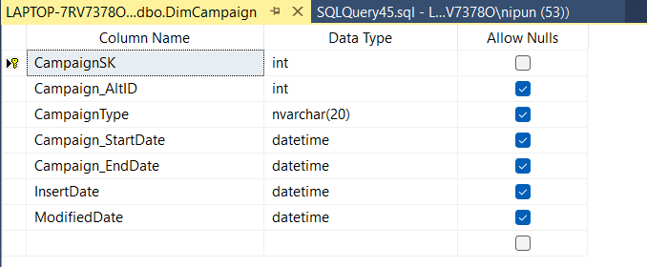

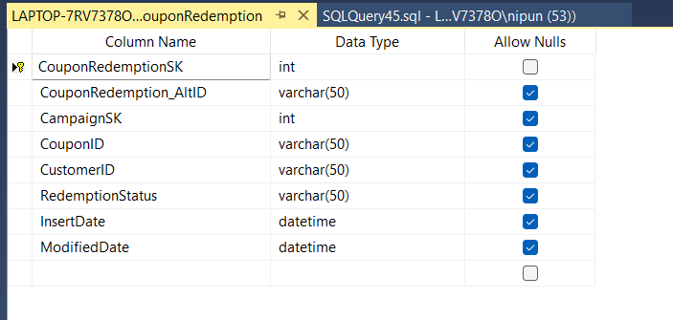

**Campaign Dimension Table**  **Coupon Redemption Dimension Table**

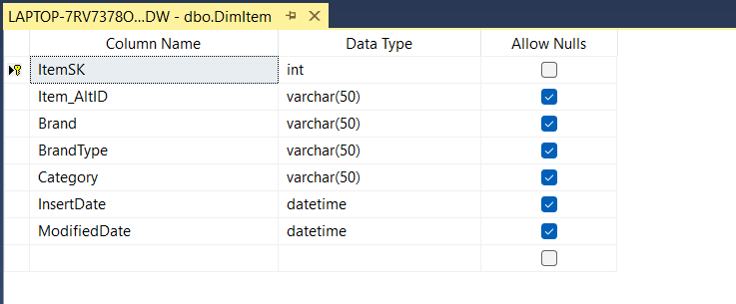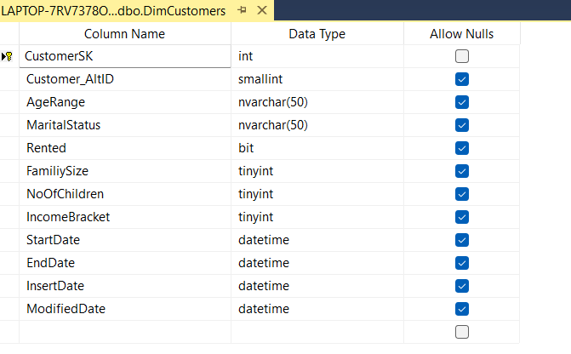

**Customer Dimension Table** **Item Dimension Table**

**Fact Customer Transaction Table**

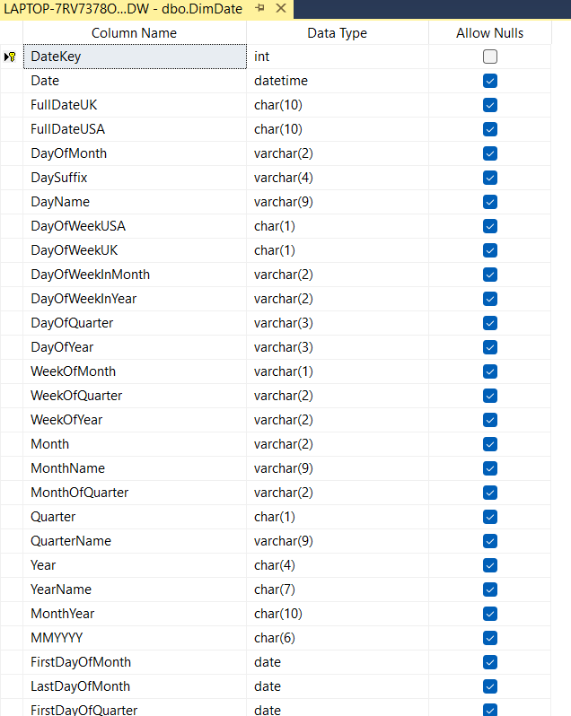

**Date Dimension Table**

**STEP 05: ETL Development**

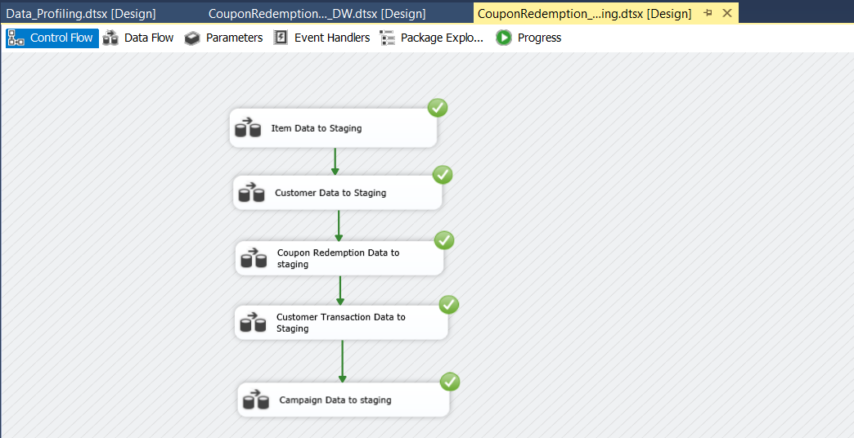

* First using the SQL Server integration service Software, I have extracted all the data from the Tables which were in the CouponRedmption_SourceDB and Extract Campaign_Data.txt to Separate DB called CouponRedemption_Staging. And also, **here I converted train.csv data into** **CouponRedemptionStaging table**.

**CouponRedemption_Staging DB**

1. Graphical user interface, text

   Description automatically generated with medium confidence **Extract Coupon Redemption Data to Staging**

* Used OLE DB Source as dbo.train data table in CouponRedemption_SourceDB.
* OLE DB Destination for create new table CouponRedemptionStaging table in the CouponRedemption _Staging database.

* Used to execute SQL Task SSIS tool truncate table for SQL command as truncate table CouponRedemptionStaging in CouponRedemption_Staging database.

1. Graphical user interface, text, chat or text message

   Description automatically generated**Extract Item Data to Staging**

* Used OLE DB Source as dbo.item_data table in CouponRedmption_SourceDB.
* OLE DB Destination for create new table ItemStaging table in the CouponRedmption _Staging database.

* Used to execute SQL Task SSIS tool truncate table for SQL command as truncate table ItemStaging in CouponRedemption_Staging database.

1. **Extract Customer Data to Staging**

* Used OLE DB Source as dbo.Customer_demographocs table in CouponRedmption_SourceDB. OLE DB Destination for create new table CutomerStaging in the CouponRedmption _Staging database. Used to execute SQL Task SSIS tool truncate table for SQL command as truncate table CutomerStaging in CouponRedemptio_Staging database.

1. **Extract Campaign Data to Staging**

* Used OLE DB Source as **Campaign_data.txt Flat** **File Source.**
* Graphical user interface, text, chat or text message

  Description automatically generatedOLE DB Destination for create new table CampaignStaging in the CouponRedmption_Staging database.
* Used to execute SQL Task SSIS tool truncate table for SQL command as truncate table CampaignStaging in CouponRedemption_Staging database.

**5. Extract Customer transaction Data to Staging**

* Used OLE DB Source as dbo.customer_transaction_data_new table in CouponRedmption_SourceDB.
* Graphical user interface, text, application, chat or text message

  Description automatically generatedOLE DB Destination for create new table CustomerTransactionStaging in the CouponRedmption _Staging database.

Used to execute SQL Task SSIS tool truncate table for SQL command as truncate table CustomerTransactionStaging in CouponRedemption_Staging database.

**Data Profiling**

* I used the staging table data to analyze how the data looks like to determine what type of transformations I need to perform on the data.

* Data Profiling was done to all staging tables to get a better insight on the data like checking for unique values or if null values were present. CustomerStaging table data profiling shown below.

**Data Transformation**

1. **Transform and Load Item Data Details**

I created Item data transformation by below mentioned steps.

* Created new package called CouponRedemption_DW.dtsx.
* Then dragged and dropped a data flow task, renamed it as transform and load

Item Data.

* Then dragged and dropped OLE DB source renamed as Extract from Item Staging and configure it to access the Item staging table.
* After that I dragged and OLE DB Command and connect to the OLE DB source.

* First, I have created a procedure called UpdateDimItem and executed in the CouponRedemption_DW database.
* 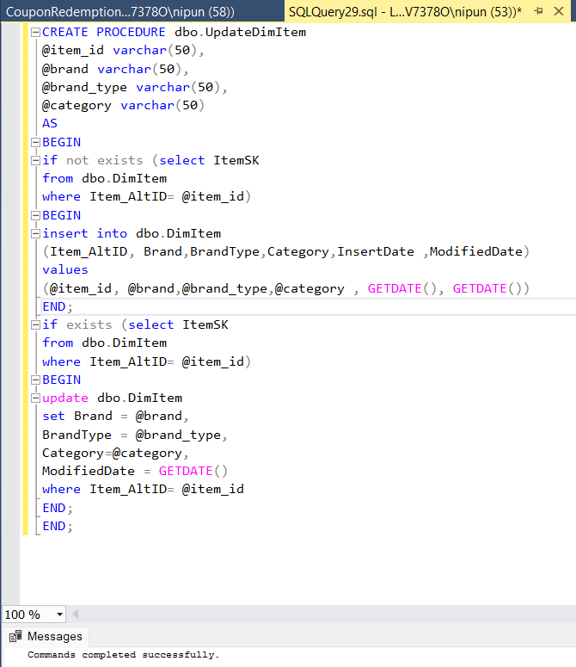**UpdateDimItem procedure**, it is used to insert data from ItemStaging to DimItem without data duplication.
* Then I did same process to DimCouponRedemption table and DimCampaign table as well.

1. **Transform and Load Coupon Redemption Data Details**

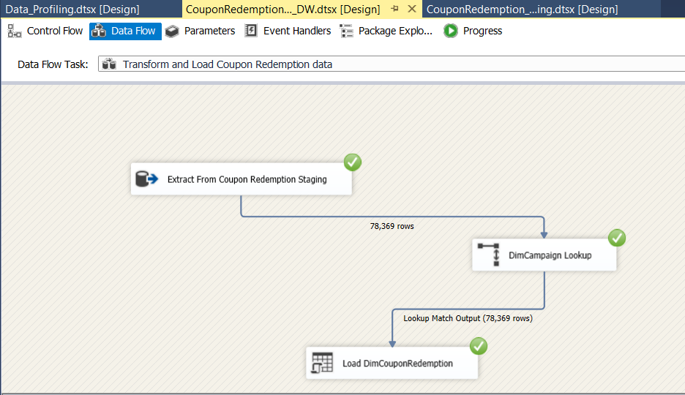

**UpdateDimCouponRedemption Procedure**

1. 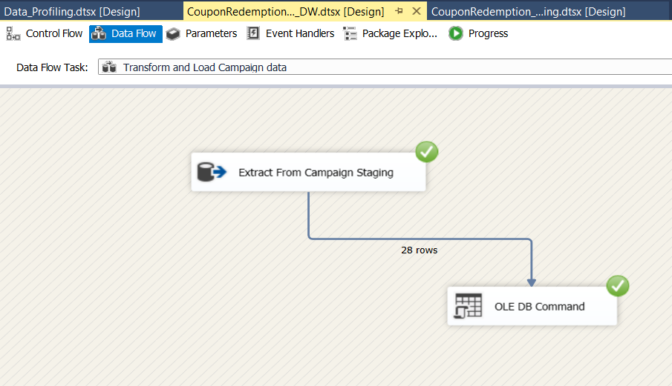**Transform and Load Campaign Data Details**

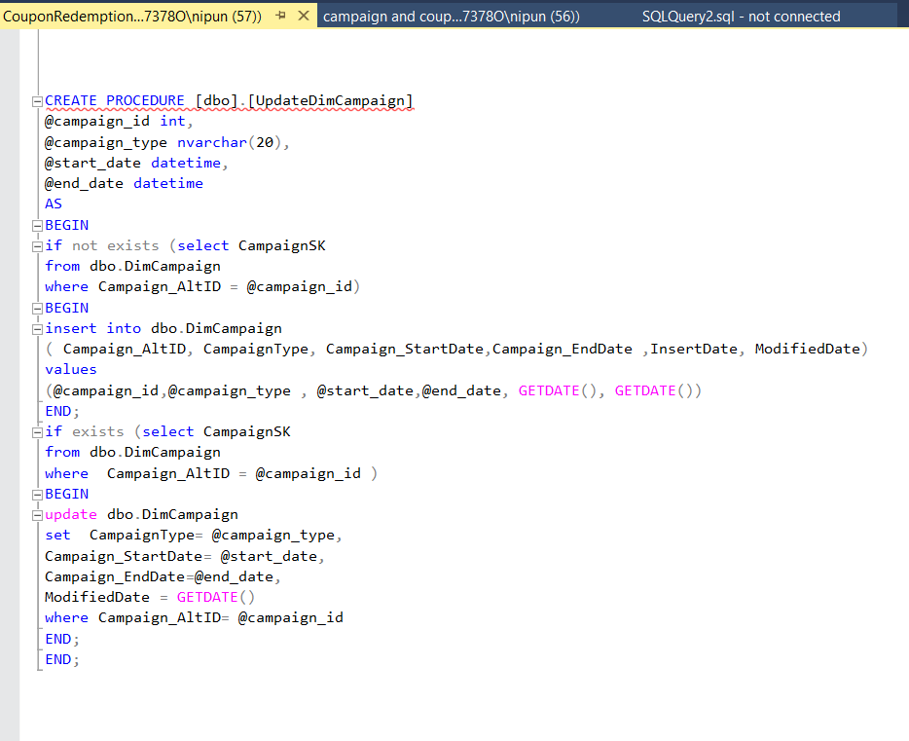 **UpdateDimCampaign Procedure**

**Transform and Load Customer Data Details (Slowly Changing Dimension)**

* The slowly Changing Dimension was handled when creating the DimCustomers table. For the slowly changing dimension I have used a slowly changing dimension, derived columns, merge, union, and sort in order to do the ETL process of loading data to the warehouse from the staging.

**Transform and Load Customer Transaction Data Details**

**CouponRedemption_DW**

**STEP 06: ETL Development -Accumulating Fact Table**

First, I extended my fact table (FactCustomerTransaction Table) with following 03 coloumns.

* + accm_txn_create_time
  + accm_txn_complete_time
  + txn_process_time_hours

* Then I prepared a dataset which contains fact table natural key(tID) and accm_txn_complete time and saved it csv file format.

s

* Then I created a separate ETL SSIS package named as **Complete_time.dtsx.** Which reads data from this file and update the corresponding accm_txn_complete time in my DW Fact table.

s

**Final Control CouponRedemption_DW Control Flow.**

**Finally, successfully loaded data to the FactCustomerTransaction table with updated txn_process_time.**

